## Problem 1 – Daggers and Swords

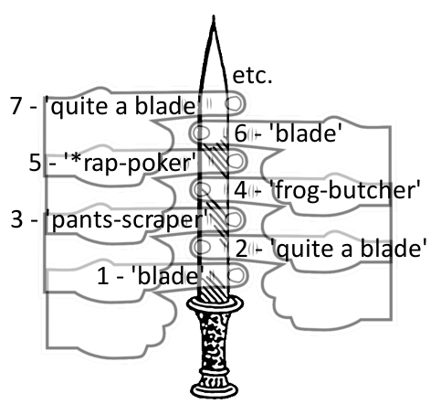There is a small antiques store in downtown Sofia. The salesman name is Grandpa Ancho. He sells **daggers and swords (blades)** amongst other stuff. Grandpa Ancho classifies his blades in a very special medieval way. There are **5 blade types** according to their **application**: **'blade'**, **'quite a blade'**, **'pants-scraper'**, **'frog-butcher'** and **'*rap-poker'**.

He checks the length of the blade by counting in **index finger widths** (see the picture on the right).Let **n** be the length of the blade. For example if the blade is long **1 or 6 etc. (n*5 + 1)** index finger widths, the blade type of application is **'blade'**. If the blade is long **2 or 7 etc. (n*5 + 2)** index finger widths, the blade type of application is **'quite a blade'**. If the blade is long **3 or 8 etc. (n*5 + 3)** index finger widths, the blade type of application is **'pants-scraper'**. If the blade is long **4 or 9 etc. (n*5 + 4)** index finger widths, the blade type of application is **'frog-butcher'**. If the blade is long **5 or 10 etc. (n*5 + 5)** index finger widths, the blade type of application is **'*rap-poker'**.

Before you **start checking the type of the blade application**, you must **round down** the blade length to an integer number. Also, if the **blade is longer than 40cm**, it is a **sword**. Otherwise it is a **dagger**.

We assume that the **index finger width** of Grandpa Ancho is **1cm** (elegant fingers, ha ☺).

Help Grandpa Ancho to classify all his blades in the store. He will give you **a list of the blade lengths**. Your task is to **find the blade type of application** and whether it is a **sword or a dagger.** You must **print** the information inan **HTML table**: the first column holds the rounded **blade length**; the second column holds the **type of the application** of the blade; the third column holds the **type of the blade** (sword or dagger). See the example below to understand your task better.

### Input

The input is passed to the first JavaScript function found in your code as **array of strings** holding the input numbers.

* Each input number represents the **length** of the given blade.

The input data will always be valid and in the format described. There is no need to check it explicitly.

### Output

Print at the console the blades HTML table following the examples below. The table has a fixed header defining 3 columns: **Blade Length, Blade Type** and **Blade Application**. **Whitespace** and character **casing** are important, so please use the same as in the below examples. If a blade is **10cm or shorter**, it is **not printed** in the output.

### Constraints

* The **count** of input blade lengths is in the range [0…1 000].
* All **input blade lengths** are in the range [0…1 000].
* There will **always be** at least one blade, **longer than 10cm**.
* Allowed working time: 0.2 seconds. Allowed memory: 16 MB.

### Example

|  |  |
| --- | --- |
| **Input** | **Output** |
| 17.8  19.4  13  55.8  126.96541651  3 | <table border="1">  <thead>  <tr><th colspan="3">Blades</th></tr>  <tr><th>Length [cm]</th><th>Type</th><th>Application</th></tr>  </thead>  <tbody>  <tr><td>17</td><td>dagger</td><td>quite a blade</td></tr>  <tr><td>19</td><td>dagger</td><td>frog-butcher</td></tr>  <tr><td>13</td><td>dagger</td><td>pants-scraper</td></tr>  <tr><td>55</td><td>sword</td><td>*rap-poker</td></tr>  <tr><td>126</td><td>sword</td><td>blade</td></tr>  </tbody>  </table> |

Enjoy your life folks ☺